# Informações do estudo

Referência: Chinchanikar 35

Grandeza: Força

Tipo: Fx

Material: AISI 4340 (35 HRC)

Ferramenta: KC9110

Número de experimentos: 20

Observações:  
Tool holder: PCBNR 2020K12  
Diameter: 90 mm  
Piezo-electric dynamometer: KISTLER Type 9257A  
Surface roughness tester: Qualitest TR100

# Unidades

Velocidade: m/min

Avanço: mm/rev

Profundidade de corte: mm

Força: N

# Dados de teste

|  |  |  |  |
| --- | --- | --- | --- |
| Força | n | f | a |
| 555.0 | 200.0 | 0.3 | 1.5 |
| 253.0 | 200.0 | 0.1 | 1.5 |
| 605.0 | 200.0 | 0.2 | 2.5 |
| 362.0 | 300.0 | 0.2 | 1.5 |

# Dados de treino

|  |  |  |  |
| --- | --- | --- | --- |
| Força | n | f | a |
| 377.0 | 142.0 | 0.25 | 1.0 |
| 553.0 | 142.0 | 0.25 | 2.0 |
| 361.0 | 200.0 | 0.2 | 1.5 |
| 402.0 | 265.0 | 0.25 | 1.0 |
| 350.0 | 200.0 | 0.2 | 1.5 |
| 257.0 | 200.0 | 0.2 | 0.5 |
| 351.0 | 200.0 | 0.2 | 1.5 |
| 441.0 | 100.0 | 0.2 | 1.5 |
| 376.0 | 200.0 | 0.2 | 1.5 |
| 361.0 | 265.0 | 0.15 | 2.0 |
| 532.0 | 265.0 | 0.25 | 2.0 |
| 383.0 | 200.0 | 0.2 | 1.5 |
| 287.0 | 142.0 | 0.15 | 1.0 |
| 219.0 | 265.0 | 0.15 | 1.0 |
| 480.0 | 142.0 | 0.15 | 2.0 |
| 391.0 | 200.0 | 0.2 | 1.5 |

# RN

Número de neurônios: 25

Taxa de aprendizado: 1.000000e-01

Número de épocas: 562

2° camada: True

Função de ativação: relu

# Erros

**Dados de teste**

* Erro relativo médio: 4.6
* Coeficiente de correlação: 0.99
* Coeficiente de determinação: 0.98
* MSE: 680.39
* RMSE: 26.08

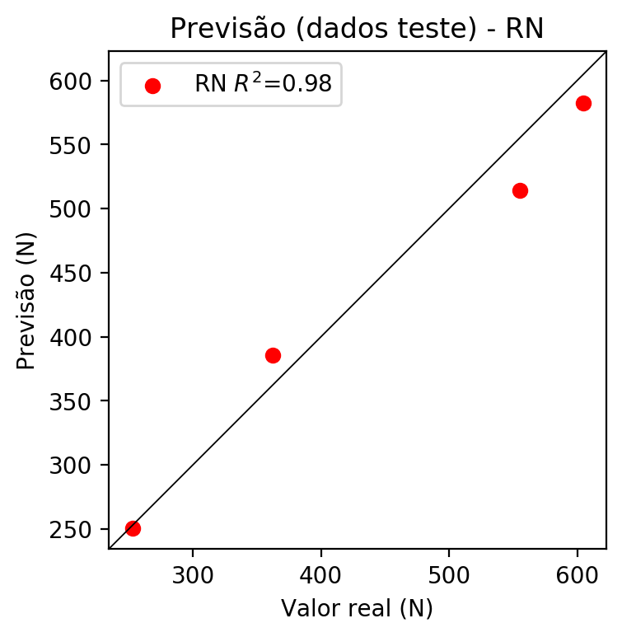

**Dados de treino**

* Erro relativo médio: 1.49
* Coeficiente de correlação: 0.99
* Coeficiente de determinação: 0.99
* MSE: 92.33
* RMSE: 9.61

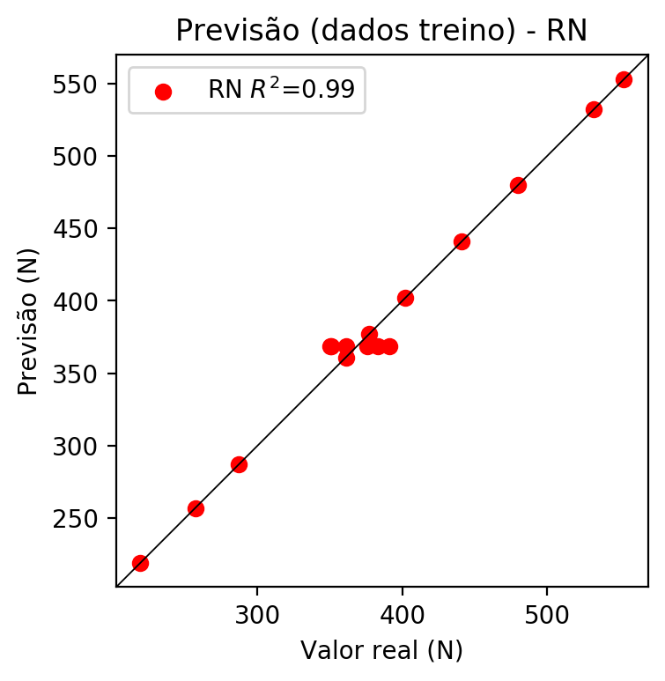

# Pesos

Pesos - camada oculta 1

[[-0.08435855 -0.02676357 0.36013082 0.1239947 0.31116906 0.3375638  
 -0.3356638 -0.06557889 0.45459652 -0.47769153 -0.6013353 -0.25538722  
 -0.18841887 -0.64807177 -0.31348523 -0.49204338 0.0186447 0.5925537  
 0.9005373 -0.1355797 0.19587849 -0.09346807 0.77360404 -1.0293137  
 -0.06943814]  
 [ 0.29073197 -0.00306151 -0.58219016 -0.35212508 -1.1278927 -0.0632407  
 0.14044118 0.47062376 -0.4813791 -0.03756144 0.78312397 -0.17118078  
 0.14713131 0.15645686 -0.32490793 -0.09906195 -0.49264127 0.49335077  
 0.77751523 -0.04952921 -0.6822303 -0.73539734 0.93614906 0.26416224  
 0.59012 ]  
 [ 0.87808263 -0.13014168 -1.2045188 -0.39010093 -0.570702 0.37847522  
 0.18051822 0.11625618 -0.48033223 0.1023707 1.110036 0.22109495  
 0.75159985 0.7102628 1.0255489 -0.08698963 0.23523133 -0.17196645  
 0.29231182 0.48908025 0.22114532 0.36635002 0.49253318 0.523058  
 0.4523602 ]]

Bias - camada oculta

[-0.18476649 -0.51065606 -0.22821751 -0.32200226 0.08684593 -0.63755256  
 -0.7054731 -0.76956975 -0.321096 -0.5541004 -0.2769748 -0.59561217  
 -0.45817 -0.5189399 -0.13353188 -0.40563443 -1.1435037 -0.12716168  
 -0.7077284 -0.6479769 -0.4556813 -0.60581976 -0.81139284 -0.94092065  
 -0.15659472]

Pesos - camada oculta 2

[[-0.3148868 0.14657454 -0.19132204 0.01851123 0.6148192 -0.7685732  
 -0.36055395 -0.12466998 0.0340249 -0.6999972 -0.10925762 -0.6878943  
 -0.83048785 -0.19044773 -0.76454335 -0.02102514 -1.0163441 -0.9042962  
 -1.1384804 -0.31986818 -0.05617006 -0.3589427 -0.6911888 0.17156664  
 -0.13137366]  
 [ 0.15495783 0.45561412 -0.74918026 0.24997318 0.02975714 -0.33126274  
 -0.78340477 -0.38811612 -0.82343143 0.46372822 -0.38506803 0.09440545  
 0.5077153 -0.87029046 -0.7164236 -0.47421283 0.55747014 -0.30960438  
 -0.5330491 0.55618036 0.38509002 -0.0050576 -1.1472248 0.21133874  
 -0.47224858]  
 [ 0.5164232 -0.25446233 0.12035687 -0.7835746 -0.13685523 -0.5000796  
 -0.1361379 0.05198841 -0.93972194 0.28034422 0.5646756 0.11418402  
 -0.8922497 0.02604052 0.27741662 -0.5985901 0.30926007 -0.6381594  
 -1.1171452 -0.79284096 0.54402167 -0.55993074 -1.1510392 -0.85154486  
 -0.26555434]  
 [-0.48065296 0.11369139 -0.0575011 -0.0331489 -0.02333991 -0.11326274  
 -0.70859087 -0.6224085 -0.56378543 -0.42022192 0.37782654 0.7666181  
 -0.44631085 -0.5122057 0.22031817 -0.38300094 0.15259103 -1.0267016  
 -0.582641 -0.663118 -0.34246376 -0.93558365 -0.79940516 -0.21714406  
 -0.51051134]  
 [-0.45128477 -0.59079134 0.5263704 -0.71463853 -0.44544044 -0.7773457  
 -0.1703698 -0.4832006 0.03503949 -0.38613454 0.39169818 -0.76325756  
 -0.30847326 0.30496457 0.20607173 0.5291654 -0.6182797 -0.21322612  
 -0.4530736 -0.80598915 -0.43830854 -0.83532846 -0.70644295 -0.97212285  
 0.34664565]  
 [ 0.52126265 0.24113365 -0.04736242 -0.6903139 -0.10043118 -0.38248754  
 0.05227452 -0.15823819 -1.0413018 0.84737825 0.19778727 0.34419796  
 -0.4679783 -0.14353271 -0.06638067 -0.1928375 0.48102134 -0.56506455  
 -0.8483848 -0.60120815 0.31365213 -0.29324847 -0.7298701 -0.5675506  
 -0.6873153 ]  
 [-0.12925829 -0.63265526 -0.11411268 -0.72062725 0.37769714 -1.1295489  
 0.17102322 0.37202665 0.15860872 -0.6322797 0.23698768 -0.19675256  
 -0.8556186 -0.14291403 -0.5655061 -0.2074637 -0.7291408 0.4071284  
 -0.30226928 -0.7378449 -0.40557146 -0.4022442 -1.1181002 -0.3916021  
 -0.13129358]  
 [-0.3553044 0.02249101 0.5360843 0.30916396 0.17755984 -0.36394763  
 0.2528474 0.30086496 0.04599352 -0.66422814 0.27136362 -0.12258299  
 -0.3127645 0.04265089 -0.6879241 0.20620193 -0.8082947 0.4026419  
 0.04091224 -0.4514926 -0.5339405 -0.36339378 0.6818852 -0.73888403  
 0.11790922]  
 [-0.35342187 -0.54344416 0.568995 -0.2270377 -0.21162924 -0.53563094  
 -0.21618362 -0.3491292 -0.13484295 -0.35311577 0.40138105 -0.62939906  
 -0.86316526 0.23686154 0.2538556 0.22879335 -0.44754598 0.7225818  
 0.20132825 -0.4657093 -0.3311168 -0.4614199 -0.67827785 -0.40674996  
 0.3512026 ]  
 [-0.7947805 0.32272065 -0.33797628 0.44995904 0.05113998 -0.7005297  
 -0.500666 -0.40681645 -0.6039438 -0.32216957 0.20662639 -0.7591061  
 -0.71138096 0.14368811 -0.3301194 -0.00523884 -0.666989 0.63788563  
 -0.2905441 -0.47249094 -0.3875615 -0.5601633 -0.31484675 -0.78607166  
 -0.1134543 ]  
 [ 0.45562395 -0.2248804 -0.28388196 -0.5716206 0.6925214 -0.6691847  
 -0.26883867 0.23360224 -0.5345812 -1.2354785 -0.81409615 0.2882003  
 -0.95730925 -0.5532776 -0.9591365 -0.43626773 -0.5305532 -0.84050596  
 -0.9038984 -0.5134517 0.39402768 -0.52783483 -0.9970733 -0.90799046  
 -0.4204239 ]  
 [-0.5576427 0.59793854 -0.32978374 0.30323502 0.4436858 -0.42140758  
 -0.09184878 -0.7480746 -0.49786344 -0.52931094 0.32632345 -0.49053147  
 -0.55724806 -0.24157697 -0.16313414 -0.13888186 -0.336111 -1.049359  
 -0.11266071 -0.32647985 -0.30493838 -0.6736422 -0.6024536 -0.5406256  
 -0.14490043]  
 [-0.70556647 0.12462062 -0.48040748 0.53196317 0.41385558 -0.24912444  
 -0.40881747 -0.2502142 -0.14274332 -0.6391335 0.11767486 -1.2239956  
 -0.49096617 -0.3184855 -0.04148788 -0.07313856 -0.3308737 -0.7117154  
 -0.3532933 -0.38243312 -0.632628 -0.7790797 -0.3945633 -0.68294585  
 -0.60189366]  
 [-0.57798755 -0.45143798 -0.62916154 -0.33022526 0.4684191 -0.85629815  
 -0.13262926 -0.08860232 -0.31538168 -0.39343545 -0.29301298 -0.50134224  
 -0.29574895 -0.20485474 -0.8999472 -0.14946067 -1.3945256 0.6279305  
 -0.07601243 -0.5514903 0.03906911 -0.4950596 -0.7961312 -0.9426446  
 -0.22412255]  
 [ 0.49352655 -0.20459513 -0.75244874 -0.57339525 0.50697744 -0.9079041  
 -0.38104406 0.40420544 -0.29032898 0.6043168 -0.20775889 0.07803588  
 -0.8645185 -0.27961546 -0.53234583 -0.21101838 -0.05424108 -0.51641846  
 -0.29843548 0.36852494 0.7211891 -0.7204082 -0.6185025 -0.32449046  
 -0.29925698]  
 [-0.49373263 -0.0283624 -0.27099657 -0.05052387 0.18267177 -0.2204521  
 -0.2852518 -0.1832546 -0.73826027 -0.74737847 0.25478297 -0.4906275  
 -0.24289519 0.13085595 0.2540668 -0.5919698 -0.5080272 0.21335723  
 -0.03529847 -0.813796 -0.79157895 -0.4814243 -0.23260976 -1.0129744  
 -0.00912475]  
 [-1.0997152 0.08397973 -0.37237138 0.13943715 0.4079513 -0.42744967  
 -0.5269662 -0.16677916 -0.52735364 -0.26654023 -0.34925508 -0.9411659  
 -0.5791373 -0.02526514 -0.23794672 -0.50145537 -0.33922973 -0.8913708  
 -0.34151882 -0.9394047 -0.9166752 -0.7018305 -0.5409406 0.47638905  
 -0.2638601 ]  
 [ 0.52066 0.11863875 -0.6332821 0.22130352 0.444708 -0.46146417  
 -0.3759449 0.22312339 -0.7579829 0.11887671 -0.02782695 0.0050254  
 0.0092836 -0.3849054 -0.24662477 -0.35284966 -0.31098494 -0.49017924  
 -0.87143004 0.22161214 0.53359365 0.32028636 -0.66541356 -0.16500986  
 -0.9769836 ]  
 [-0.399215 0.14231843 -0.6906374 -0.12634076 0.4233699 -0.3186869  
 -0.08278258 0.2114821 -0.64977646 -0.82541597 -0.06044491 0.015424  
 -0.4971145 -0.46889812 -0.4341443 -0.19566838 -0.86331916 -0.53084517  
 -0.7122822 -0.3263603 -0.18654369 -0.62589115 -0.75041384 -0.97161794  
 0.01637478]  
 [-0.6454745 0.175964 -0.54071945 0.24047877 0.30708486 -0.58182293  
 -0.45872304 -0.7962492 -0.34486035 -0.22248927 0.12701783 -1.062434  
 -0.3668469 -0.1512915 -0.3365606 -0.16530678 -0.75918525 -0.6572324  
 -0.18271808 -0.31252035 -0.5102694 -0.67047036 -0.39715117 0.16177936  
 -0.65637547]  
 [-0.30725172 0.25491634 0.10038862 -0.1617876 0.07585625 -0.19351348  
 -0.00871903 -0.5449668 0.02681474 -0.66756505 0.3716936 -1.0783029  
 -0.72235733 0.14739378 -0.00254405 0.17164959 -0.87179816 -0.7286496  
 -0.7187302 -0.9093035 -0.560112 -0.655857 -0.7632063 -0.5130081  
 -0.06744979]  
 [-0.6761262 0.19847357 0.13585553 0.30684918 0.5675469 -0.8015802  
 -0.23932602 -0.01053719 0.06605573 -0.4255534 0.15038277 -0.9752004  
 -0.70137876 -0.12485065 -0.15049124 0.15775654 -0.48314986 -0.70365655  
 -0.77619493 -0.36336026 -0.20000085 -0.30177706 -0.35636327 -0.1926416  
 -0.0470521 ]  
 [-0.5960732 0.9144314 0.49599555 0.54386365 1.0556376 -0.2998541  
 -0.10720468 0.24343261 0.27758622 -1.013423 0.01897642 -0.6191901  
 -0.6941333 0.28027195 -0.5872194 0.36151648 -0.9317263 0.6470834  
 0.3762913 -0.36279458 -0.13707891 -0.8449454 -0.96127796 -0.08236615  
 -0.14031453]  
 [-0.39596206 0.39928976 -0.24292335 0.27190045 0.35135722 -0.29277292  
 -0.8018986 -0.66659045 -0.25644344 -0.39245343 -0.24227066 -0.61124974  
 -0.50793695 -0.20219623 -0.19210981 -0.5145582 -0.57793385 -0.55135876  
 -0.4971913 -0.3328585 -0.47764632 -0.2544275 -0.5702463 -0.29114646  
 -0.22166657]  
 [ 0.49890965 -0.03985988 -0.98972297 -0.10444053 0.62873125 -0.53014  
 -0.9008857 0.2233468 -0.59931004 0.23223475 -0.26618063 -0.18033463  
 -0.4972336 -0.31567508 -0.7136211 -0.77834386 -0.14500597 -0.7657305  
 -0.52279156 0.23333195 0.7083848 0.46342355 -0.95541024 0.27471447  
 -0.7094377 ]]

Bias - camada oculta 2

[-0.47401136 -0.20481403 0.04701073 -0.31063095 0.11939758 -0.18361141  
 -0.21338095 -0.4015539 -0.2525531 -0.8156964 0.2549958 -0.5444007  
 -0.7869143 -0.06297036 0.06677452 -0.06488927 -1.0450062 -0.4023493  
 -0.6886484 -0.5900687 -0.31371742 -0.600544 -0.60362864 -0.45527261  
 -0.1752857 ]

Pesos - camada saída

[[-0.08272413 -0.12973966 -0.14100325 -0.0681788 0.32042235 0.38929856  
 0.29836124 -0.01914379 0.11100009 -0.42537966 -0.3469889 -0.27999082  
 -0.16516493 0.01709222 -0.0596801 -0.01493543 -0.01101864 0.5828051  
 0.04958658 -0.25939155 0.0480927 -0.26552072 -0.09205255 0.04000707  
 0.09055841]]

# Iterações

|  |  |  |  |  |  |  |
| --- | --- | --- | --- | --- | --- | --- |
| Média | Desvio | n | ln | 2° camada | Função | Épocas |
| -0.2143 | 0.1678 | 10 | 0.1 | False | relu | 38 |
| -0.123 | 0.0415 | 17 | 0.1 | True | relu | 716 |
| -0.1839 | 0.1096 | 7 | 0.01 | True | tanh | 130 |
| -0.344 | 0.2072 | 19 | 0.001 | False | tanh | 282 |
| -0.207 | 0.2094 | 29 | 0.001 | False | relu | 469 |
| -0.7396 | 0.9939 | 88 | 0.1 | False | tanh | 926 |
| -0.1902 | 0.2114 | 95 | 0.0001 | True | relu | 984 |
| -0.2338 | 0.1044 | 10 | 0.01 | True | tanh | 865 |
| -0.5112 | 0.2721 | 58 | 0.001 | True | relu | 8 |
| -0.2618 | 0.074 | 9 | 0.01 | False | tanh | 514 |
| -0.1899 | 0.113 | 73 | 0.0001 | True | relu | 729 |
| -0.2361 | 0.1598 | 22 | 0.001 | True | relu | 543 |
| -0.0932 | 0.0371 | 25 | 0.1 | True | relu | 562 |
| -0.2778 | 0.251 | 53 | 0.001 | False | relu | 498 |
| -0.1709 | 0.1386 | 83 | 0.01 | True | relu | 337 |
| -0.286 | 0.1807 | 99 | 0.01 | False | tanh | 16 |
| -0.1214 | 0.1174 | 23 | 0.01 | False | relu | 472 |
| -0.1577 | 0.0725 | 24 | 0.001 | True | relu | 778 |
| -0.2413 | 0.159 | 58 | 0.01 | True | tanh | 382 |
| -0.659 | 0.6665 | 35 | 0.1 | False | tanh | 596 |

# RL

# Coeficientes

[ 0. -0.19298934 0.5602682 0.65560249]

# Erros

**Dados de teste**

* Erro relativo médio: 5.81
* Coeficiente de correlação: 1.0
* Coeficiente de determinação: 1.0
* MSE: 1373.24
* RMSE: 37.06

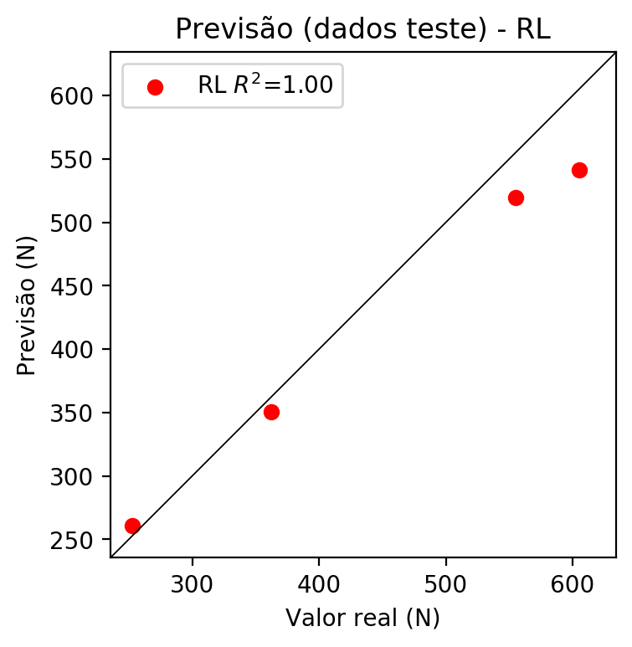

**Dados de treino**

* Erro relativo médio: 5.81
* Coeficiente de correlação: 0.95
* Coeficiente de determinação: 0.9
* MSE: 749.82
* RMSE: 27.38

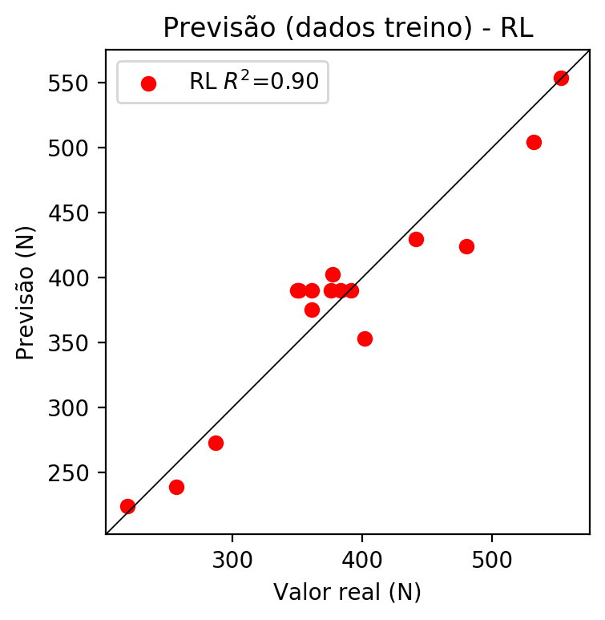

# RP2

# Coeficientes

[ 0. -0.18753869 0.55320042 0.69823527 0.08216134 0.17319821  
 -0.0879593 0.07270588 -0.02883943 0.09937353]

# Erros

**Dados de teste**

* Erro relativo médio: 4.61
* Coeficiente de correlação: 1.0
* Coeficiente de determinação: 1.0
* MSE: 453.15
* RMSE: 21.29

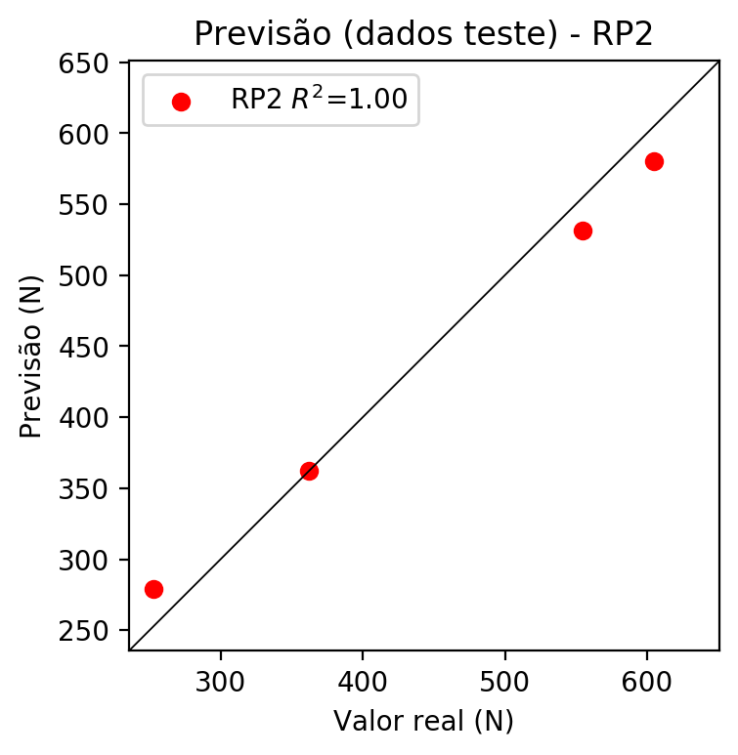

**Dados de treino**

* Erro relativo médio: 1.58
* Coeficiente de correlação: 0.99
* Coeficiente de determinação: 0.99
* MSE: 92.53
* RMSE: 9.62

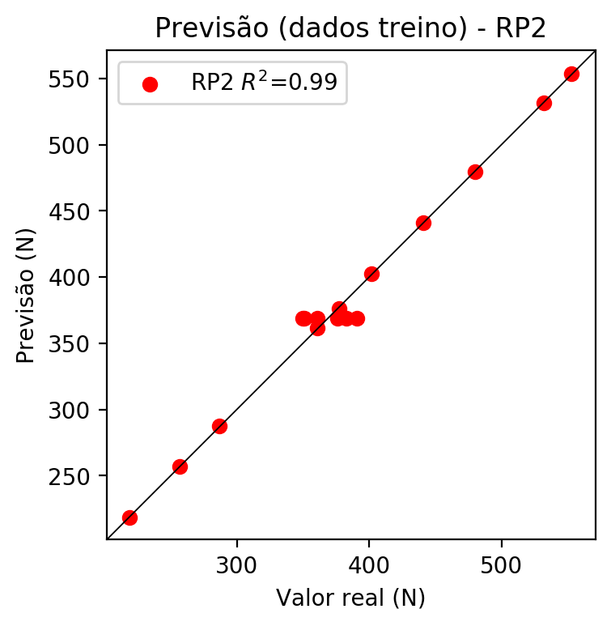

# RP3

# Coeficientes

[-5.89805982e-17 -3.24496799e-02 9.12668966e-02 1.22296445e-01  
 8.53486108e-02 1.61496546e-01 -1.02388565e-01 7.60170426e-02  
 -2.90092128e-02 9.23868815e-02 -3.77765276e-02 1.43376465e-01  
 1.76796920e-01 -4.23911214e-02 4.16066946e-03 -4.28364625e-02  
 1.08379440e-01 1.54146337e-01 1.08379440e-01 1.18469100e-01]

# Erros

**Dados de teste**

* Erro relativo médio: 3.55
* Coeficiente de correlação: 1.0
* Coeficiente de determinação: 1.0
* MSE: 320.36
* RMSE: 17.9

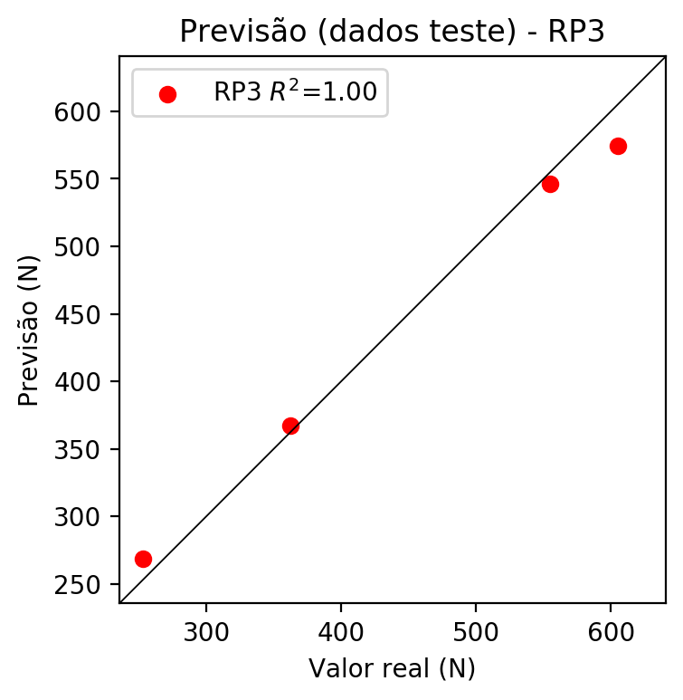

**Dados de treino**

* Erro relativo médio: 1.49
* Coeficiente de correlação: 0.99
* Coeficiente de determinação: 0.99
* MSE: 92.33
* RMSE: 9.61

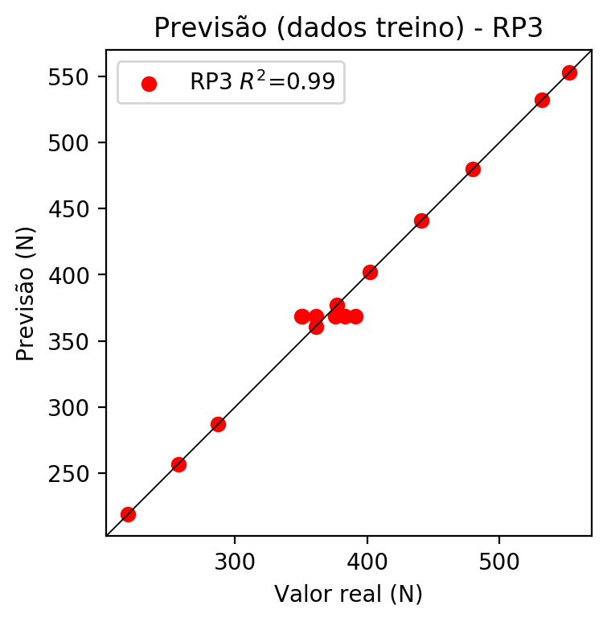

# RP4

# Coeficientes

[-5.37764278e-17 -3.29833521e-02 9.30546759e-02 1.19960489e-01  
 2.01975281e-02 2.49678118e-02 -2.07300637e-02 2.25262263e-02  
 -5.04811752e-03 2.23210746e-02 -4.08473584e-02 1.34784023e-01  
 1.69302628e-01 -4.21307705e-02 4.71698684e-03 -4.21251893e-02  
 1.10502428e-01 1.42341301e-01 1.10502428e-01 1.42788419e-01  
 1.51500523e-02 4.66179861e-02 -1.57510115e-02 2.86960777e-02  
 -6.81636826e-03 2.86959258e-02 2.96492765e-02 -2.46139097e-02  
 2.96492765e-02 -2.46260735e-02 2.67498938e-02 -5.99463955e-03  
 2.67498938e-02 -5.99463955e-03 2.57754230e-02]

# Erros

**Dados de teste**

* Erro relativo médio: 7.32
* Coeficiente de correlação: 0.99
* Coeficiente de determinação: 0.98
* MSE: 985.56
* RMSE: 31.39

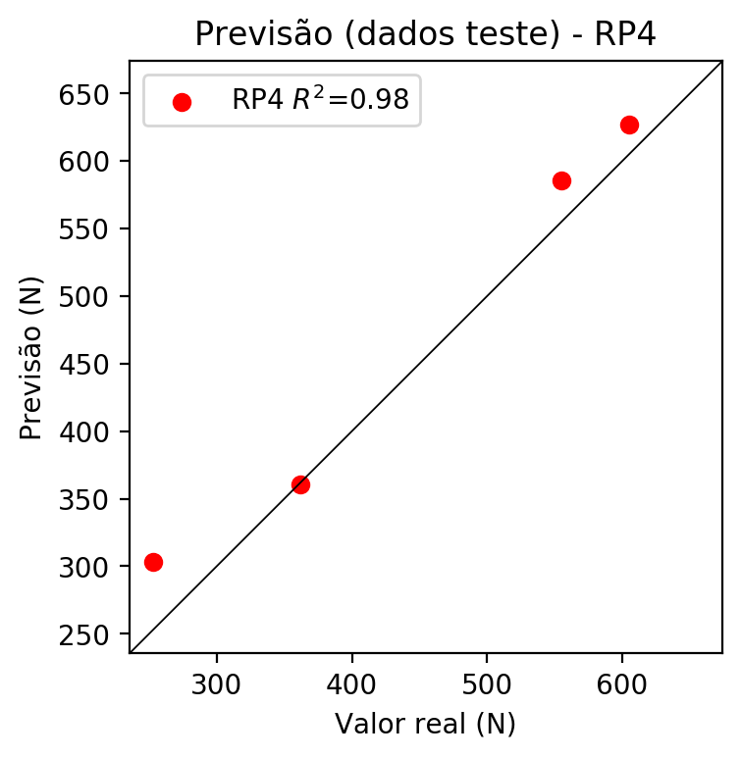

**Dados de treino**

* Erro relativo médio: 1.49
* Coeficiente de correlação: 0.99
* Coeficiente de determinação: 0.99
* MSE: 92.33
* RMSE: 9.61

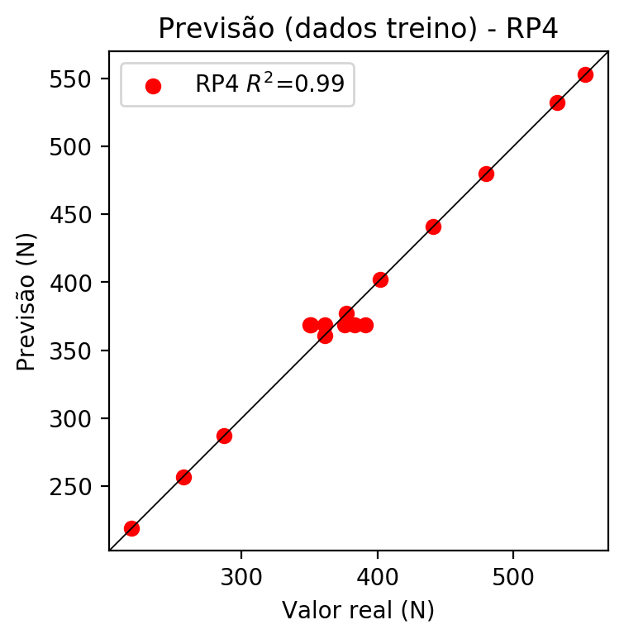

# Geral

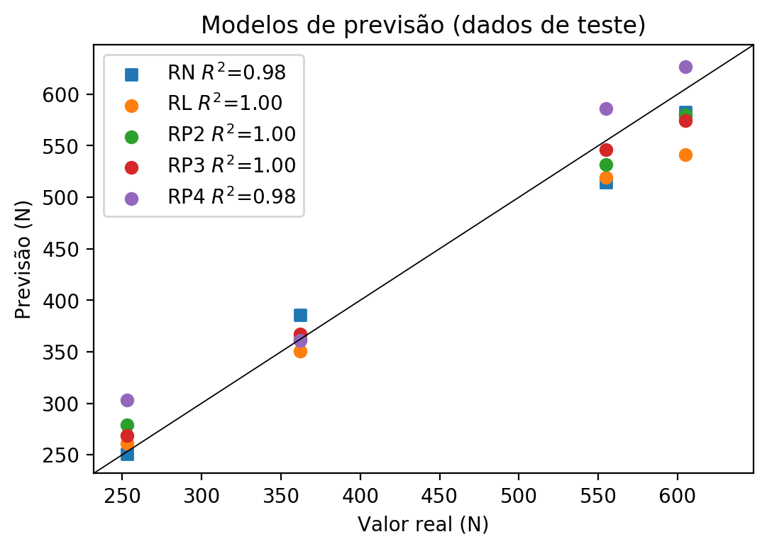

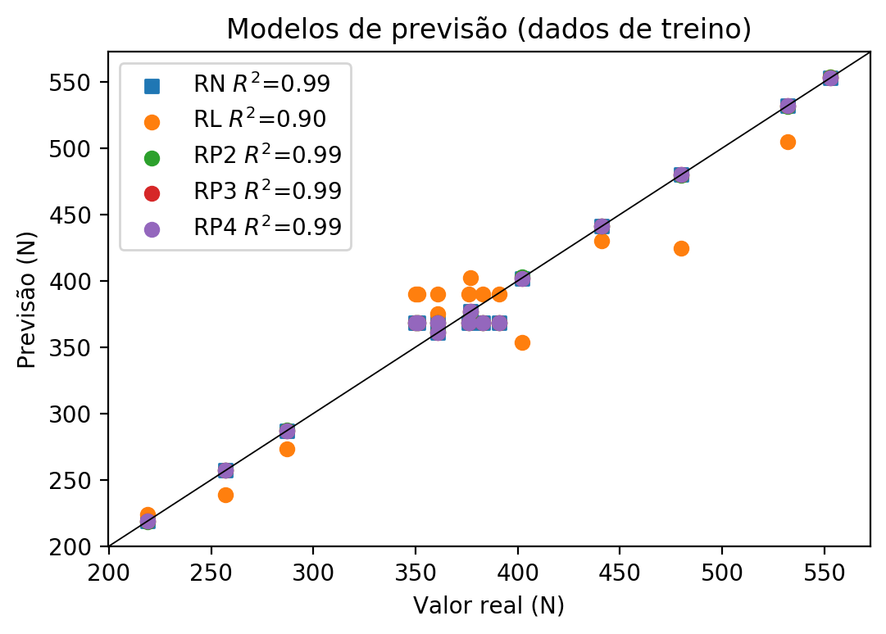

**Dados de teste**

|  |  |  |  |  |  |  |  |  |  |  |
| --- | --- | --- | --- | --- | --- | --- | --- | --- | --- | --- |
| Valor real | RN Previsto | RN Erro (%) | RL Previsto | RL Erro (%) | RP2 Previsto | RP2 Erro (%) | RP3 Previsto | RP3 Erro (%) | RP4 Previsto | RP4 Erro (%) |
| 555.0 | 514.18 | 7.35 | 519.48 | 6.4 | 531.75 | 4.19 | 546.29 | 1.57 | 586.0 | 5.59 |
| 253.0 | 250.78 | 0.88 | 260.98 | 3.15 | 278.69 | 10.15 | 268.64 | 6.18 | 302.93 | 19.74 |
| 605.0 | 582.64 | 3.7 | 541.47 | 10.5 | 580.26 | 4.09 | 574.41 | 5.06 | 627.07 | 3.65 |
| 362.0 | 385.46 | 6.48 | 350.53 | 3.17 | 362.01 | 0.0 | 367.02 | 1.39 | 360.93 | 0.3 |

**Dados de treino**

|  |  |  |  |  |  |  |  |  |  |  |
| --- | --- | --- | --- | --- | --- | --- | --- | --- | --- | --- |
| Valor real | RN Previsto | RN Erro (%) | RL Previsto | RL Erro (%) | RP2 Previsto | RP2 Erro (%) | RP3 Previsto | RP3 Erro (%) | RP4 Previsto | RP4 Erro (%) |
| 377.0 | 377.0 | 0.0 | 402.26 | 6.7 | 376.38 | 0.16 | 377.0 | 0.0 | 377.0 | 0.0 |
| 553.0 | 553.0 | 0.0 | 553.5 | 0.09 | 553.62 | 0.11 | 553.0 | 0.0 | 553.0 | 0.0 |
| 361.0 | 368.67 | 2.12 | 390.23 | 8.1 | 368.67 | 2.12 | 368.67 | 2.12 | 368.67 | 2.12 |
| 402.0 | 402.0 | 0.0 | 353.43 | 12.08 | 402.63 | 0.16 | 402.0 | 0.0 | 402.0 | 0.0 |
| 350.0 | 368.67 | 5.33 | 390.23 | 11.49 | 368.67 | 5.33 | 368.67 | 5.33 | 368.67 | 5.33 |
| 257.0 | 257.0 | 0.0 | 238.99 | 7.01 | 257.0 | 0.0 | 257.0 | 0.0 | 257.0 | 0.0 |
| 351.0 | 368.67 | 5.03 | 390.23 | 11.18 | 368.67 | 5.03 | 368.67 | 5.03 | 368.67 | 5.03 |
| 441.0 | 441.0 | 0.0 | 429.92 | 2.51 | 441.0 | 0.0 | 441.0 | 0.0 | 441.0 | 0.0 |
| 376.0 | 368.67 | 1.95 | 390.23 | 3.78 | 368.67 | 1.95 | 368.67 | 1.95 | 368.67 | 1.95 |
| 361.0 | 361.0 | 0.0 | 375.42 | 3.99 | 361.62 | 0.17 | 361.0 | 0.0 | 361.0 | 0.0 |
| 532.0 | 532.0 | 0.0 | 504.67 | 5.14 | 531.37 | 0.12 | 532.0 | 0.0 | 532.0 | 0.0 |
| 383.0 | 368.67 | 3.74 | 390.23 | 1.89 | 368.67 | 3.74 | 368.67 | 3.74 | 368.67 | 3.74 |
| 287.0 | 287.0 | 0.0 | 273.01 | 4.87 | 287.62 | 0.22 | 287.0 | 0.0 | 287.0 | 0.0 |
| 219.0 | 219.0 | 0.0 | 224.18 | 2.37 | 218.37 | 0.29 | 219.0 | 0.0 | 219.0 | 0.0 |
| 480.0 | 480.0 | 0.0 | 424.25 | 11.61 | 479.38 | 0.13 | 480.0 | 0.0 | 480.0 | 0.0 |
| 391.0 | 368.67 | 5.71 | 390.23 | 0.2 | 368.67 | 5.71 | 368.67 | 5.71 | 368.67 | 5.71 |